

**Product Dissection for LinkedIn**

**Company Overview:**

The company was founded in December 2002 by Reid Hoffman and the founding team members from PayPal and Socialnet.com. LinkedIn is currently headquartered in Sunnyvale, California, with 33 global offices. In 2016, the company was acquired by Microsoft and by December 2022, the company had around 21,000 employees.

LinkedIn connects the world's professionals to make them more productive and successful. With more than 1 billion members worldwide, including executives from every Fortune 500 company, LinkedIn is the world's largest professional network. The company has a diversified business model with revenue coming from Talent Solutions, Marketing Solutions, Sales Solutions and Premium Subscriptions products.

**Product Dissection and Real-World Problems Solved by LinkedIn:**

LinkedIn has effectively addressed real-world challenges through its innovative service offerings. With a focus on effective networking, LinkedIn empowers users to authentically share their experiences and achievements, bridging the gap between job seekers and employers. By allowing users to share projects and achievement certificates accompanied by captions, certificate validation details, and hashtags, LinkedIn provides a solution to the need of relevant job opportunities for fresher as well as experienced users.This core feature solves the problem of connecting job seekers to employers and vice-versa in an increasingly digital world, enabling users to form genuine connections and engage in conversations leading to productive results in jobs as well as businesses.

LinkedIn’s engagement features, such as likes, comments, resume builder, hashtags and customized jobs recommendations have revolutionized the way people and employers search job opportunities and candidates respectively. By addressing the challenge of irrelevant and overloaded jobs, LinkedIn helps in finding only relevant opportunities, helping job seekers and employers finding new opportunities as well as candidates tailored to their interests. Furthermore, LinkedIn's introduction of hashtags has transformed content discovery by allowing users to categorize their posts with keywords. This innovative approach effectively addresses the challenge of navigating through a sea of content to find relevant information, making it easier for users to connect with content aligned with their interests and engage in conversations that matter to them.

In summary, LinkedIn's product design has successfully tackled real-world problems by providing a platform that promotes creativity, builds connections, and offers people a space where they can showcase their skills and grow in their career.

### Case Study: Real-World Problems and LinkedIn's Innovative Solutions

LinkedIn, which is a leading social media platform when it comes for job search, has not only revolutionized the way we share and consume content but has also addressed significant real-world challenges through its innovative features. By identifying user needs and leveraging technology, LinkedIn has positioned itself as a solution-driven platform that fosters connections, promotes skills showcasing, and enhances digital interactions.

#### **Problem 1: Professional Networking**

**Real-World Challenge:** As nowadays everything is becoming digital and so are our lives, it becomes a really challenging task when it comes to building connections in the professional world.

**LinkedIn’s Solution:**

LinkedIn identifies the need for professional networking in the digital world. LinkedIn’s **‘My Network’** feature allows users to connect with colleagues, industry professionals, and potential collaborators, addressing the need for a centralized professional network. Through this approach, LinkedIn effectively tackles the problem of professional networking, nurturing meaningful connections and promoting genuine interactions.

#### **Problem 2: Job Searching and Recruitment**

**Real-World Challenge:** The huge number of job postings available among different fields overwhelm users, making it challenging to discover relevant jobs aligned with their skillset. Also, it makes it difficult for recruiters to identify qualified candidates.

**LinkedIn's Solution:**

LinkedIn addresses the issue of job searching and recruitment through its innovative **"Jobs"** feature. By going to the Jobs feature at LinkedIn users can search among relevant job opportunities by adding their job role preference in their LinkedIn’s profile or they could also search for relevant jobs by title, skills, city, state or zip code.

Through the same “Jobs” feature, recruiters can also post job opportunities by specifying job details like title, company name, work-mode (on-site/ hybrid/ remote), job type (Part-time/ Full-time), etc.

This algorithm of the job recommendation system of LinkedIn ensures that users encounter job postings that align with their skillset and recruiters could also select qualified candidates. Through this approach LinkedIn resolves the problem of job searching and recruitment and thus enhancing the user experience.

#### **Problem 3: Continuous access to Industry’s changing trends**

**Real-World Challenge:** In today’s busy lifestyle, it is very hard for professionals to stay updated with the Industry latest trends and insights along with managing their jobs.

**LinkedIn's Solution:**

LinkedIn provides a platform for individuals where they can stay updated with all the trending skills and technology in industry. LinkedIn provides a news feed, company pages, and group discussions to keep you informed about the latest industry news and developments.

#### **Problem 4: Inefficient B2B Networking**

**Real-World Challenge:** Nowadays startups struggle to find potential clients and partners for growing their businesses.

**LinkedIn's Solution:**

LinkedIn offers a platform for startups and entrepreneurs to showcase their ventures, connect with investors, and explore business opportunities.

#### **Conclusion:**

In summary, LinkedIn simplifies professional networking, job searching, skill development, personal branding, and business collaboration, making it a comprehensive solution for various challenges in the professional world.

This case study showcases how LinkedIn’s user-centric approach and continuous innovation have positioned it as a leader in the social media domain, effectively shaping the way we connect and search jobs.

### Top Features of LinkedIn:

1. **User Profiles:** LinkedIn allows users to create professional profiles, offering other connections or employers to know about the user. They can write their bio, education history, mention their skills, projects, certificates, etc. This helps them to get better opportunities.
2. **My Network:** A core feature of LinkedIn is the ability of users to view their network or connections. Through the “My Network” feature users can also add new people to their network.
3. **Messages**: Conversations are the core features of any social media app. By using this feature Users can express appreciation by liking posts and sharing their thoughts through comments. Users could also use this feature to do follow-ups with employers which is often required while navigating for jobs.
4. **Connect:** The platform fosters connections through the "Connect" functionality. Users can connect other accounts to see their posts in their feed, creating a network of connections. Users can also view who is in their list of networks, enhancing transparency.
5. **Jobs:** The "Jobs" feature of LinkedIn allows users to view and apply for job postings of different companies which align with their skillset. This feature helps them to get better growth opportunities.
6. **Hashtags:** LinkedIn allows the use of hashtags also, which categorize posts and enhance discoverability. Users can add relevant hashtags to their posts, making them accessible to a broader audience.

**Schema Description:**

The schema for LinkedIn involves multiple entities that represent different aspects of the platform. These entities include Users, Posts, Comments, Likes, Connections, Hashtags, and more. Each entity has specific attributes that describe its properties and relationships with other entities.

**User Entity:**

Users are at the core of LinkedIn. The user entity contains information about each user:

* **Email_ID (Primary Key)**: The user's email address or phone number for account-related communication.
* **Full_Name**: The user's full name as displayed on their profile.
* **Bio**: A brief description that users can use to express their experience
* **Registration_Date**: The date when the user joined LinkedIn.

**Post Entity:**

Posts capture the visual content shared on the platform:

* **PostID (Primary Key):** A unique identifier for each post.
* **Email_ID (Foreign Key referencing User Entity**): The user who created the post.
* **Caption**: Text accompanying the post, providing context.
* **Image_URL**: The URL of the image or video content.
* **Location**: The tagged location associated with the post.
* **Post_Date**: The date when the post was created.

**Comment Entity:**

Comments enable users to engage in conversations around posts:

* **CommentID (Primary Key)**: A unique identifier for each comment.
* **PostID (Foreign Key referencing Post Entity):** The post being commented on.
* **Email_ID (Foreign Key referencing User Entity)**: The user who posted the comment.
* **Text**: The text of the comment.
* **Comment_Date**: The date when the comment was posted.

**Like Entity:**

Likes represent user appreciation for posts:

* **LikeID (Primary Key):** A unique identifier for each like.
* **PostID (Foreign Key referencing Post Entity):** The post being liked.
* **Email_ID (Foreign Key referencing User Entity):** The user who liked the post.
* **Like_Date:** The date when the like was registered.

**Connection Entity:**

Followers establish connections between users:

* **FollowerID (Primary Key)**: A unique identifier for each follower relationship.
* **FollowingEmail_ID (Foreign Key referencing User Entity)**: The user who is being followed.
* **FollowerEmail_ID (Foreign Key referencing User Entity)**: The user who is following.
* **Follow_Date**: The date when the following relationship was initiated.

**Hashtag Entity:**

Hashtags categorize and group content:

* **HashtagID (Primary Key):** A unique identifier for each hashtag.
* **Tag**: The actual text of the hashtag.

**Post Hashtag Entity:**

Associates posts with hashtags:

* **PostHashtagID (Primary Key)**: A unique identifier for each association.
* **PostID (Foreign Key referencing Post Entity)**: The post associated with the hashtag.
* **HashtagID (Foreign Key referencing Hashtag Entity)**: The hashtag associated with the post.

**Relationships are:**

* **Users post and Posts –** Each user can have multiple posts.
* **Users comment on Posts –** Users can comment on multiple posts, and each post can have multiple comments.
* **Users like Posts –** Users can like multiple posts, and each post can have multiple likes.
* **Users follow other Users –** Users can follow multiple users and be followed by multiple users.
* **Posts have Hashtags –** Posts can have multiple hashtags, and each hashtag can be associated with multiple posts.

**ER Diagram:**

An ER diagram represents the relationships and attributes of the entities within the LinkedIn schema. This ER diagram will serve as a visual representation, shedding light on the pivotal components of LinkedIn's data model. Through this diagram, we will have a clear idea of the interactions and connections between the entities that define the platform's dynamics.

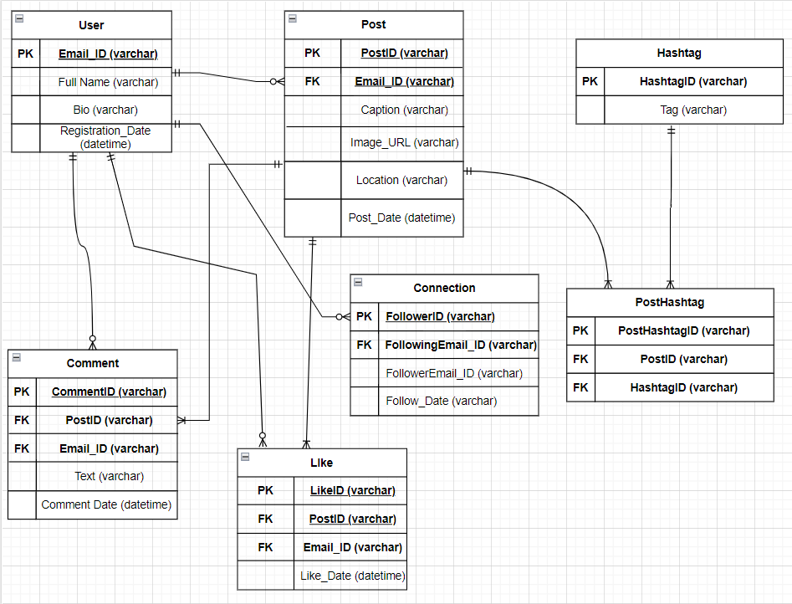

**Conclusion**

In this case study, we deep dived into the design of LinkedIn's schema and Entity-Relationship diagram. LinkedIn has revolutionized the way candidates and recruiters search for relevant opportunities and qualified candidates respectively leading to connections that lead to productivity in the professional world. The platform's intricate data model, consisting of entities like users, posts, comments, likes, connections, hashtags, and associations, forms the foundation for its seamless functionality. By understanding this schema, we gain insight into how LinkedIn effectively manages the complexities of user interactions and content sharing, job postings contributing to its global popularity and continuous growth.